LAB ASS – 8.3
A.SAI CHARAN
2403A52L08 – B50
Task 1: Email Validation using TDD
Prompt and Code:
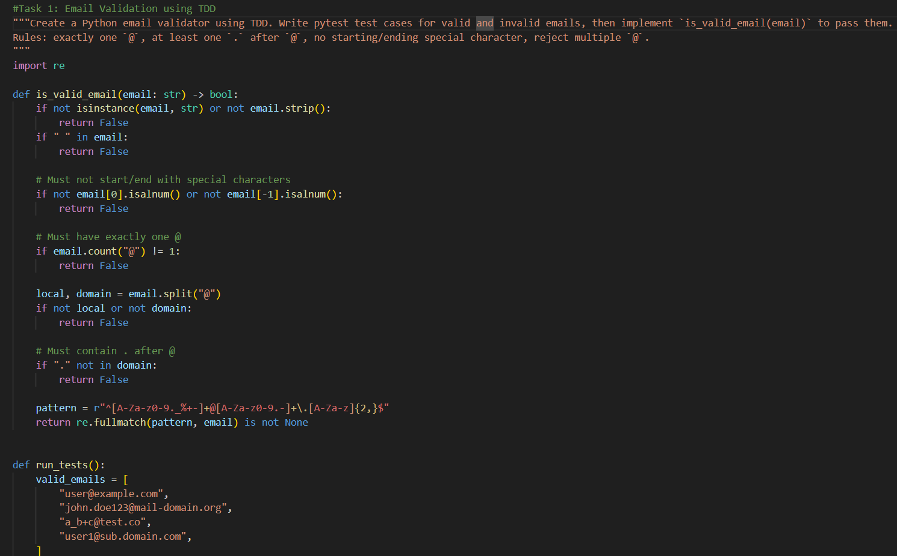
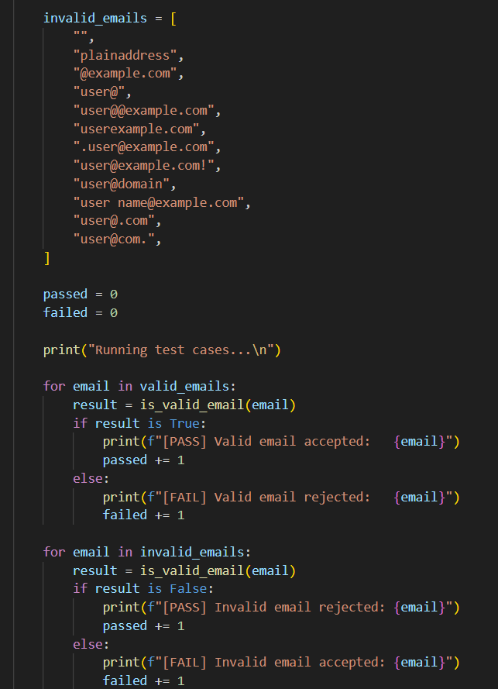
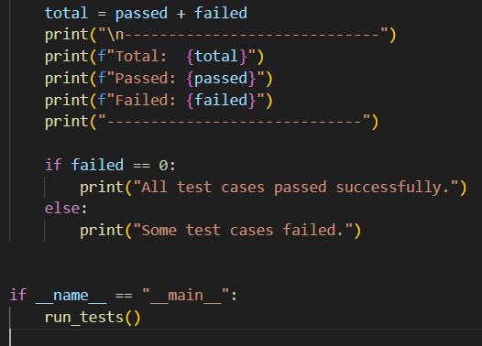
OUTPUT:
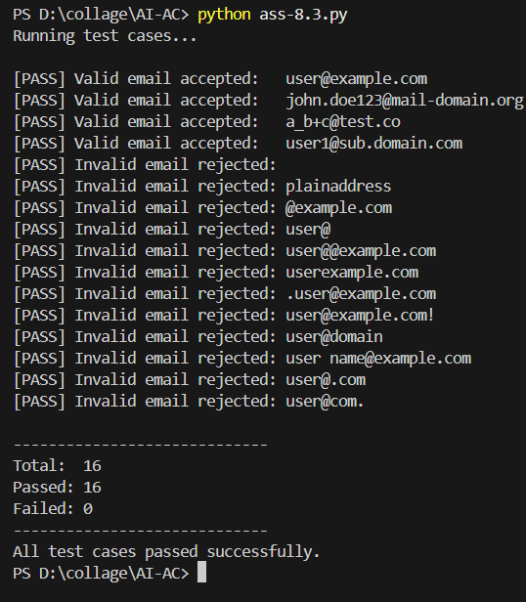
Task 2: Grade Assignment using Loops
Prompt and Code:
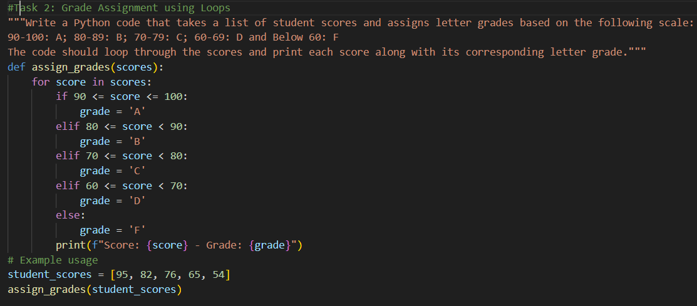
OUTPUT:
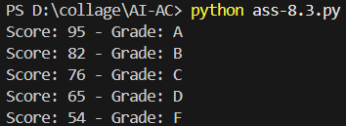

Task 3: Sentence Palindrome Checker
Prompt and Code:
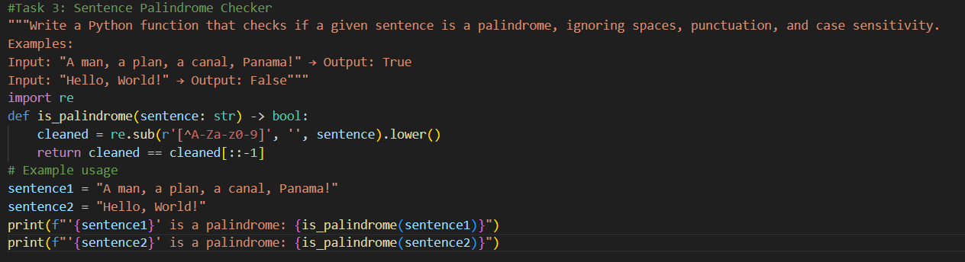
OUTPUT:
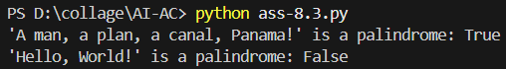

Task 4: Shopping Cart Class
Prompt and Code:
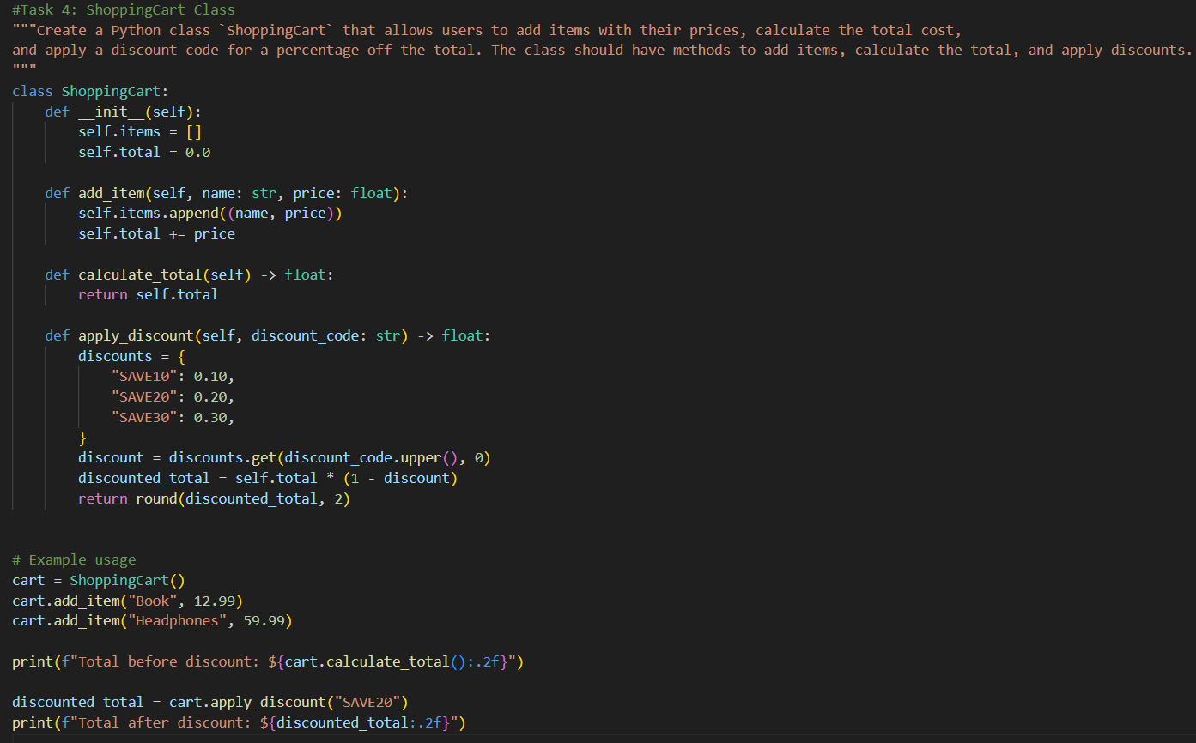
OUTPUT:
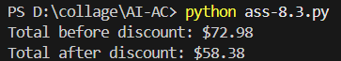
Task 5: Date Format Conversion
Prompt and Code:
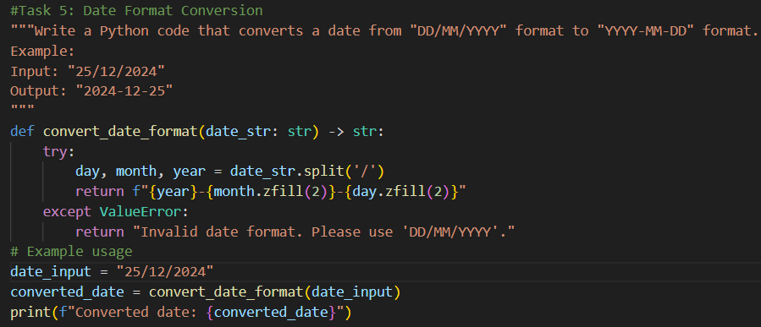
OUTPUT:
